**A Man called Sunny Singh and his legacy**

**By Zarine Bath**

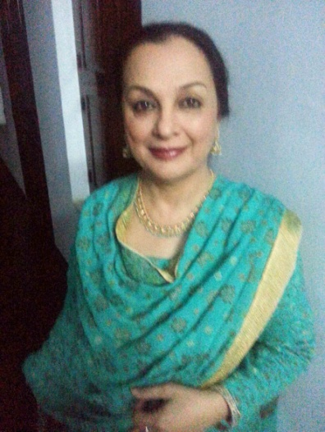

***Though Sunny Singh died in December last year, his legacy Guniyal Gaon Education Centre for girls continues to flourish. His son Aditya Singh, a senior Delhi banker, is its president now. Zarine Bath has since been running the school with her usual aplomb. -- Editor***

**THIS** is the story of a man called ‘Sunny Singh’. If he were alive today, he would have been a glorious 75 years young man. I first met Sunny in the summer of 2004 when he was engaged in building a cottage for himself in the salubrious and beautiful environs of village *Guniyal*.

Sunny was a “DOSCO” who had returned to his ‘roots’; having bought a small piece of land at a very scenic spot and built there a lovely cottage, then he started hunting for shrubs, plants, vines and creepers for his garden, travelling as far as Thailand to add to his collection. The Cottage and the little garden could have been straight out of any English countryside Home and Garden magazine.

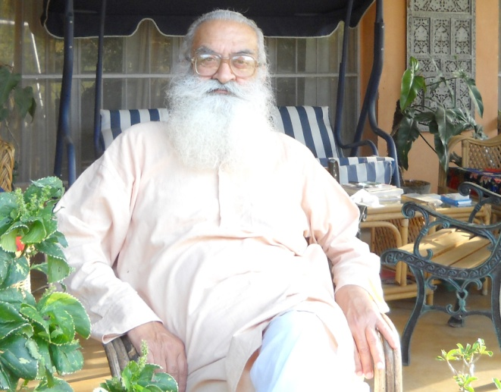Any other person would have sat back and savoured the peace and tranquility of the scenic surroundings, read books, listened to music, watched T.V or like old *faujis*, pottered around the garden and muttered around the house. But the life of a Lotus Eater was not for Sunny Singh; he realized it was “PAY BACK TIME TO SOCIETY”. After much deliberation and consultations with friends, he decided to set up a school to educate the ‘Girl Child’. Sunny went around to all the village homes selling his idea to the doubtful and reluctant villagers. Next Sunny requisitioned a room from the local *Gram Sabha* *Pradhan* and with a few chairs and tables, he set about putting his ideas in practice. Six little girls joined the school. Undaunted, Sunny hired a teacher for them. By the end of the year the numbers had swelled as the good reputation of this kind gentleman spread. So with a few bumps and many a hiccup, the school slowly established itself and everyone knew it as Sunny Sir’s school in Guniyal Gaon.

A Trust was accordingly formed to run the school; it took over the task of providing scholarships for college girls and paid for their tuition fees, books, clothes, shoes, bags and other miscellaneous expenses.

Sunny then let friends and family know what he was doing and soon the old Dosco friends and others from his Calcutta and Delhi days, well wishers, and generous people from Doon began to send donations in cash and kind (gifts) in the form of blankets and track suits in winter, shoes and school bags in summer, umbrellas in the Monsoon that were thankfully accepted; no gift was too small, everything was received with gratitude. Large quantities of old clothes, bags and shoes began pouring in; soon one could see the village lass in a Gucci shoes, carrying a Ferragamo bag, wearing a Christina blouse with as much aplomb her as city counterpart.

Friends also helped to sponsor girls through the college; Sunny personally shopped for them when he went on his holidays overseas and brought back wrist watches, smart handbags, salwar-suits, shoes, jeans etc. The college girls looked so smart that they could have come from LSR in Delhi or Sophia in Bombay, and they did him proud by passing their examinations with good grades.

Computer training was the next thing on the cards. Mr. Alok Tandon of NIIT graciously gave assistance and guidance and soon we had Deepika learning computer skills which she began to impart to the college girls.

By December 2012, the school began to prominently figure in the local Hindi and English newspapers, and attracted more supporters from amongst the Doonites. Sunny, then in his *khadi kurta pajamas* and Woodland shoes and his long flowing silver beard, was a familiar sight in the city, his car full of village girls being taken for special ‘treats’ to McDonalds, KFC, Pizza Hut, Ice creams and Elloras.

**Twice yearly picnics**

Twice a year the children were taken out on picnics, meticulously planned from what bus to be chartered and right through the food they were to partake in! Sunny accompanied them on every trip, taking them to Paonta Sahib, Rishikesh, Haridwar, Mussoorie, Chandigarh etc. His friends and well wishers sponsored all those trips, and Sunny gave the girls money from his own pocket for shopping on these excursions.

Pressure cookers were gifted to the mothers of the girls while mothers of the college-going girls were presented with food processors. It was then that Sunny decided that the families of these collegiate girls too should be financially assisted in getting them married. Despite reproachment and unsolicited advice from friends, he gave them small trousseau and a trunk full of utilities for the house and kitchen. However, none of this sidetracked him from his original vision of educating and uplifting the girl child.

Apart from Deepika, our computer teacher, Archana another young girl from the nearby areas joined the school as a teacher and soon a routine was maintained which continues to this day.

Sunny passed away peacefully in his sleep on the 10th of December, 2012 leaving a legacy behind, but he is with us in our minds and his spirit dwells around us.

My personal belief is apart from creating a school for learning to speak and write better English, he actually uplifted the ‘girl child’ of our villages, and thus created an awareness of education. For the first time in years, the girls met outside of the doors of their homes and portals of schools, they made new friends, formed their own groups, shared ideas, learned to dress with a sense of style; there were no longer unwashed faces or dirty feet and uncut nails, uncombed hair and scruffy clothes; these girls dressed like their sisters from well off families in the city. A new awareness and a new self-confidence, self-esteem and a joy of living was apparent, these girls were uplifted and set free from the shackles of ignorance. And then they were proud to be GIRLS.

In conclusion, I would like to say that, if you hear a band of happy girls singing as they walk to school they have to be ‘Sunny’s Girls’. He surely must be up there somewhere, smiling into his long bushy grey beard. Bless you Sunny. May there always be light with you wherever you may be.